User Documentation

## Vehicle Management System

~ Group 12

**WHEELz4U** is a highly interactive application designed to give users the best and easiest experience in managing transportation in and out of IITG campus.

*Note: This app is highly centric to IITG fraternity. *see footer for pre-requisites*

This app contains 5 main modules –

1. Recommendation Section
2. Short Distance Cabs
3. Long Distance Cabs
4. Campus Bus Services
5. E-rickshaw services

Its key features are -

* A RECOMMENDATION section where the user can enter his/her location and destination and get optimised options combining bus and cab services.
* Personalised Login for different userbase, with separate functionalities such as for Customers, Short Distance Cab drivers, Long Distance cab drivers and E-rickshaw drivers.
* Map based selection of locations.
* Drivers and Customers can update their information including current location of driver, fare changes, etc.
* Drivers and Customers can view their Bookings History.

## Pre-requisites

* MS Access
* And two database engines which we have bundled with this software, which need to be installed before running the software (AccessDatabaseEngine.exe, AccessDatabasefix.exe)

# Home

Welcome to WHEELz4U.

# 

The home page (as shown above) allows you to browse through the various Modules of this app. The user may Sign Up/Login as a customer, or a driver of any one of the above-mentioned transportation modes.

The user may also view available cabs, busses, or e-rickshaw without logging in.

*Note that to book a cab, users must compulsorily be logged in.*

# Login

# 

* Users (Customer, or Drivers) can login by selecting the button highlighted above.
* It will lead you to a panel as shown below.

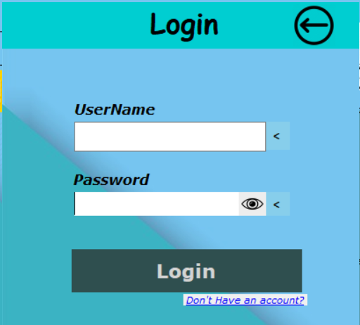

* Users must enter their credentials and login.

*Username must be unique.*

* Press the Back button (with arrow) on top right to cancel.
* Press the “Don’t have an account?” link to Sign Up as a new User.
* Your name should be Displayed in the home page after pressing login.

# Sign Up

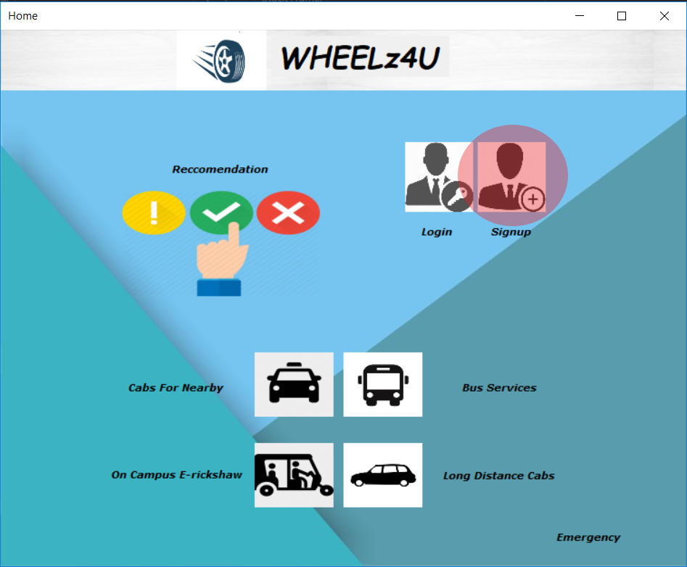

* Select the signup button from home as highlighted above. (It can also be accessed from login page).
* It will lead you to the pop-up as shown below.

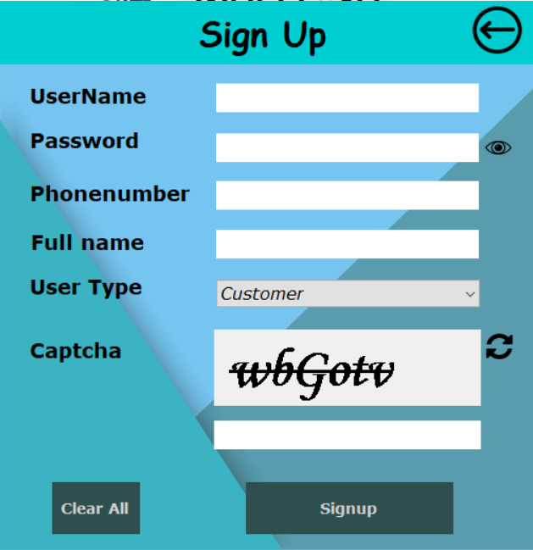

* Enter the fields with valid data.
* Use refresh button to Change Captcha.

*Important: Chose ‘User Type’ cautiously as it cannot be changed later.*

* Your name should be Displayed in the home page after pressing signup.

# Profile and Logout

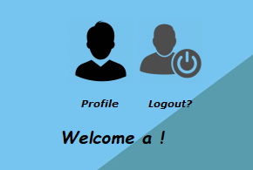

* After Signup or login, the logout and profile buttons will be accessible.
* Press the logout button to Log out as the current user.
* Pressing the ‘Profile’ button will redirect you to User Details Window where you can change your details.

*Important: Users who have signed up as drivers must first update their personal details using the Profile button before using any other feature.*

## Profile – Customer

* The customer profile is as shown below.
* Here the user can update his/her details
* and also View all past booking details by pressing the bookings Icon at the bottom of the form.

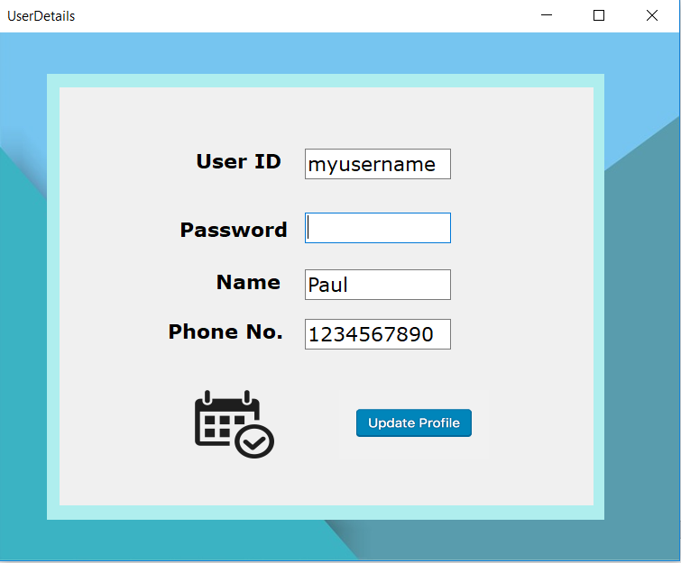

View Your Bookings

## Profile – Short Distance Driver

* Short Distance cab drivers must update details related to their contact number, Car Model, Number plate, Fare (per kilometre)
* They must also update their ‘Current location’ to help find customers nearest to them.
* Lastly, they should Check the Available box when available for service.

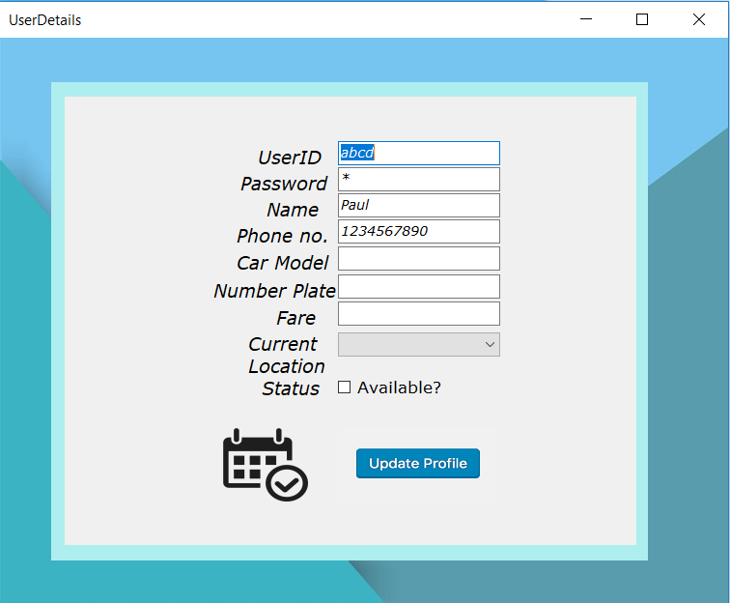

## Profile – Long Distance Driver

* Drivers must update their details as soon as the signup.
* Enter Preferred locations *one per line*.

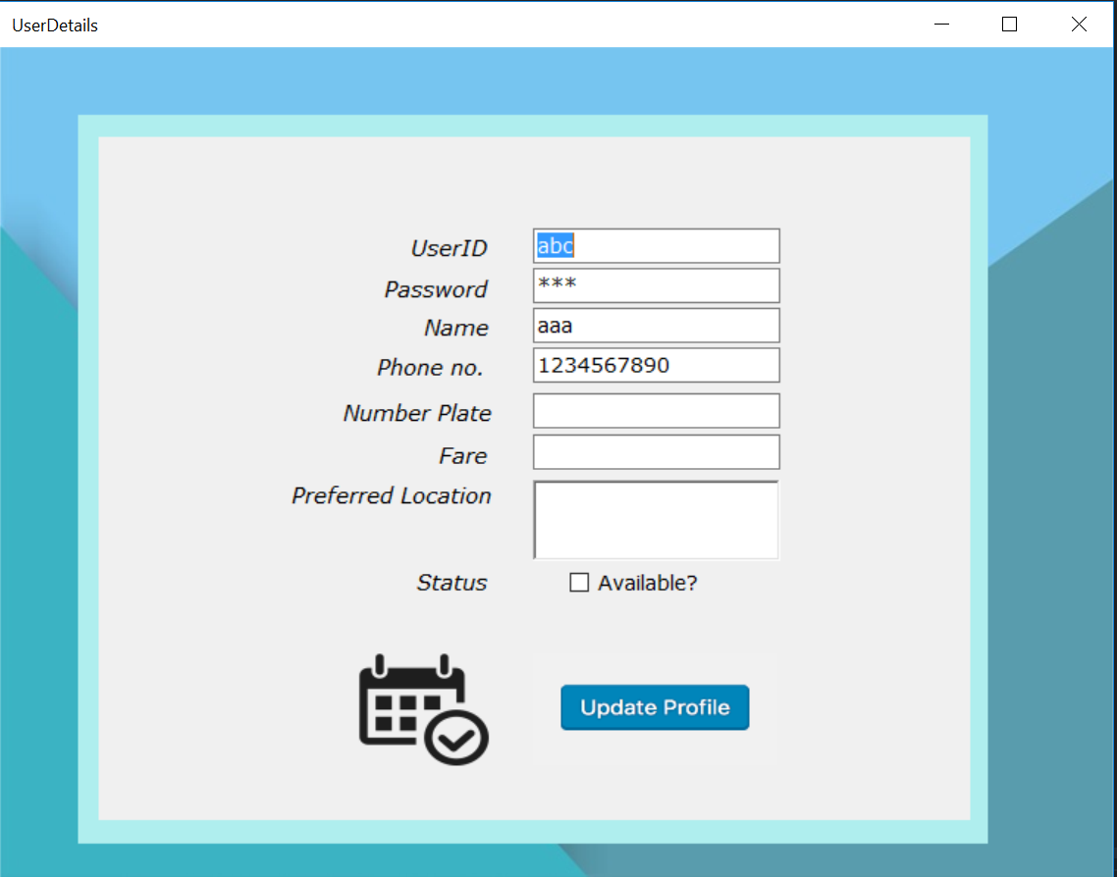

## Profile – E-rickshaw Driver

* Change personal info and current location and availability accordingly.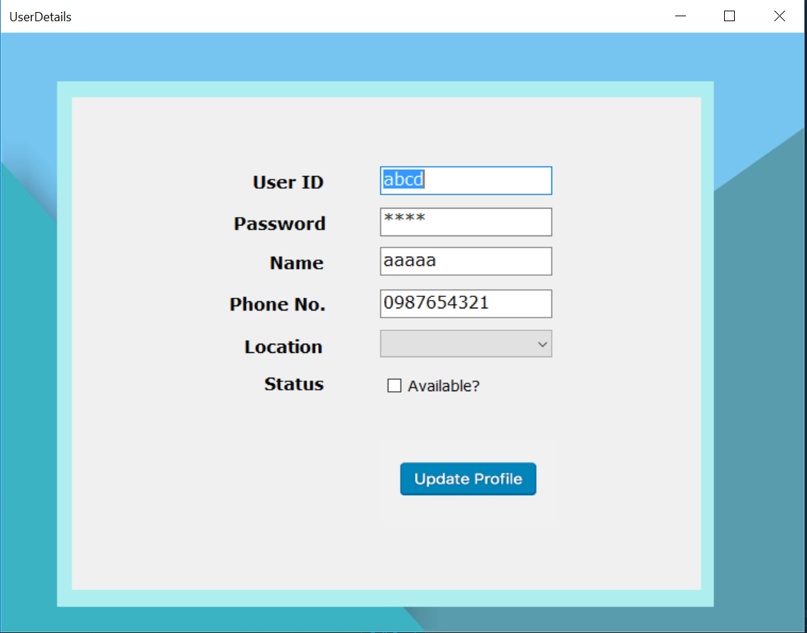

# Recommendation

The highlight of this app is the recommendation section which can be accessed by pressing the icon as highlighted below.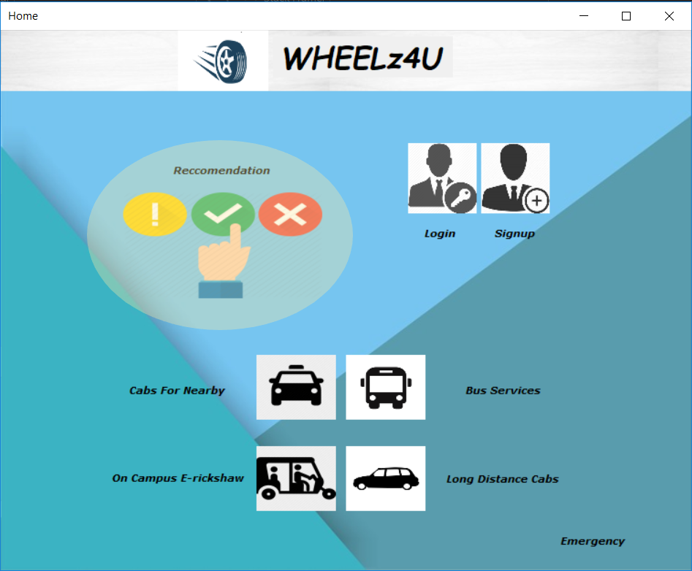

This will open the Recommendation Home page.

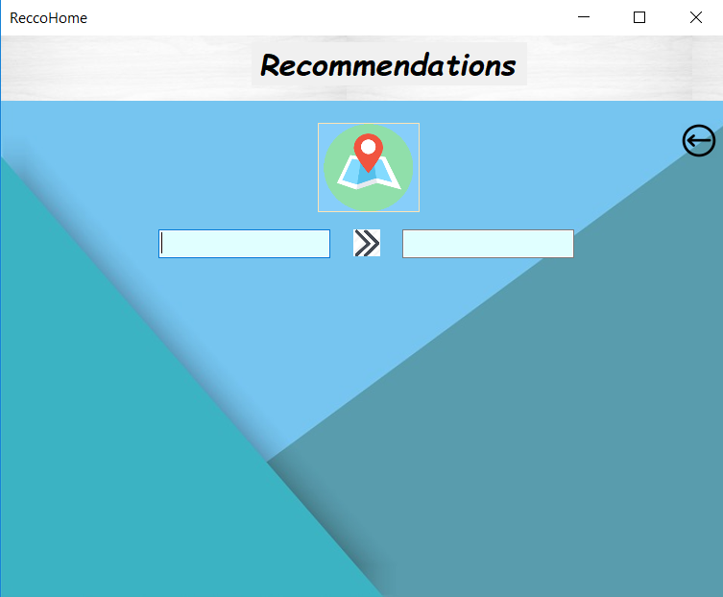

* Use the map button to open a Map of Guwahati and select appropriate locations.

*See Guwahati map section*

* Once selected, Choose the ‘Find Cabs’ button to view available options.

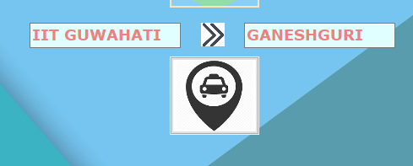

Find

Cabs

Button

* Each entry appearing shows you the possible combinations of Bus and Cab travel to go from your location to your destination.
* If your travel involves a cab, you can book that cab by selecting the appropriate radio button and pressing confirm button.

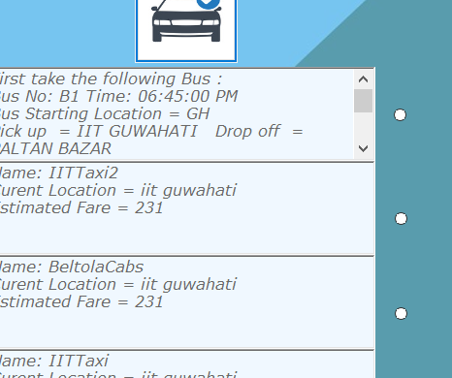

Conform

Button

* A pop-up with your Cab details, and Estimated fare shows up.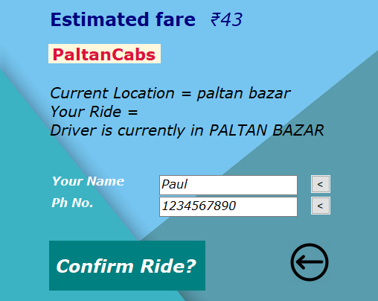
* If you want to book for another person you can update the Details of Your Name and Phone number to that of the rider, and press Confirm Ride.

# Short Distance Cabs

* It can be accessed from the button on home page as shown below.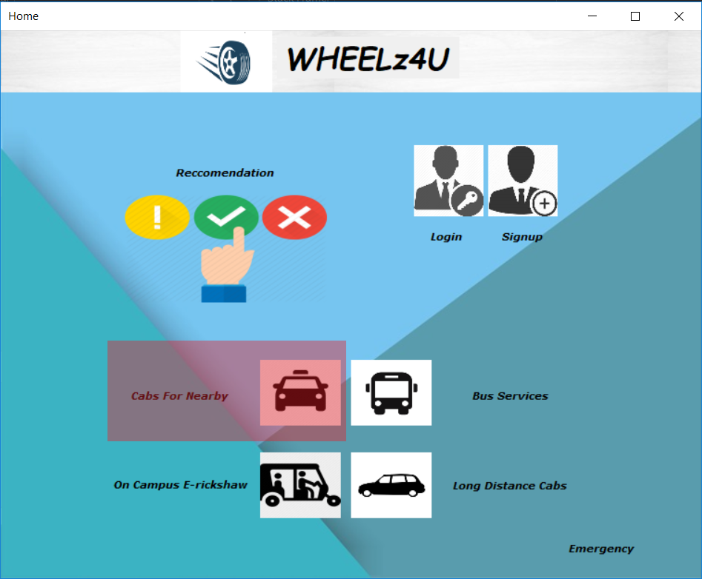
* The UI is similar to the one in Recommendation Module (see above)
* The only difference is in the Find Cabs window which will show all cabs available for the selected locations

# Guwahati Map

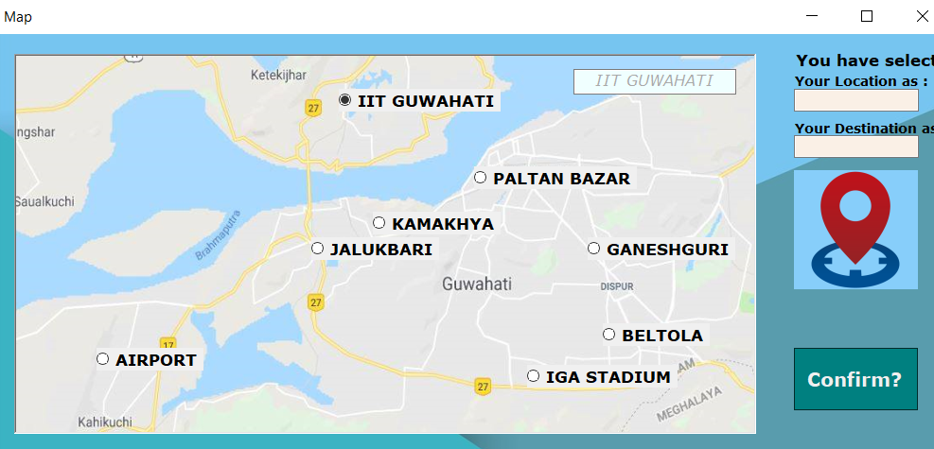

My

Location

Buttonon

* Navigate through the Hotspots and select the radio button of the location you are closest to.
* Press the My Location button.

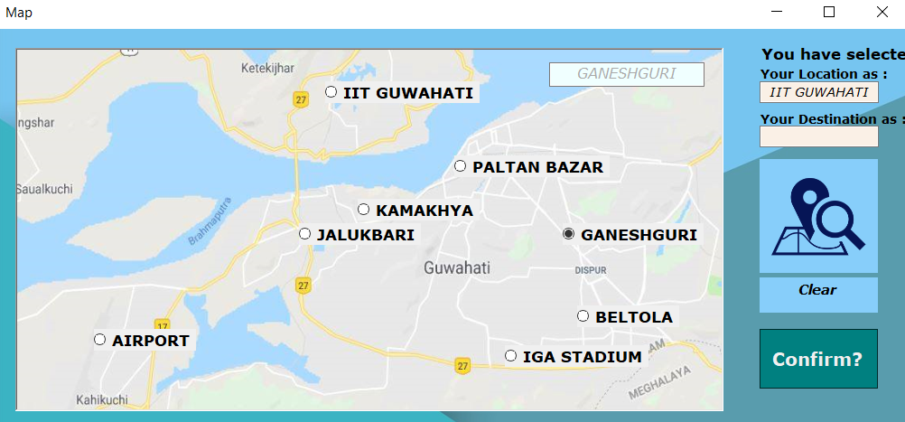

My

Destination

Button

* Similarly select your destination and press the ‘My Destination’ button outlined above.
* Press the clear button to erase entries.
* Press the ‘Confirm button to Lock Choices.

# Bus Services

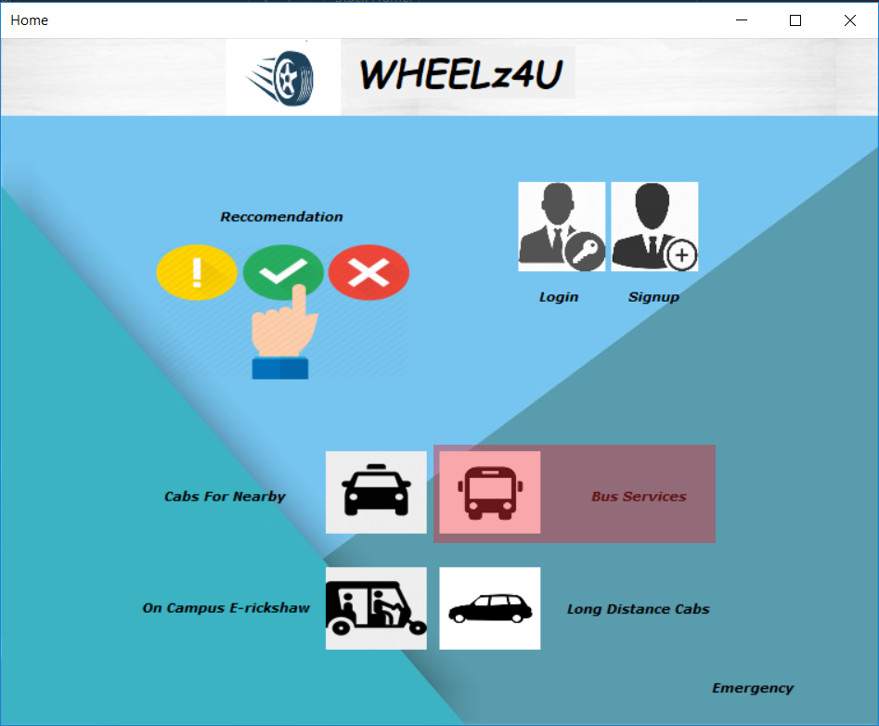

Select the Bus Services to search for the buses and it will go to the window displayed below.

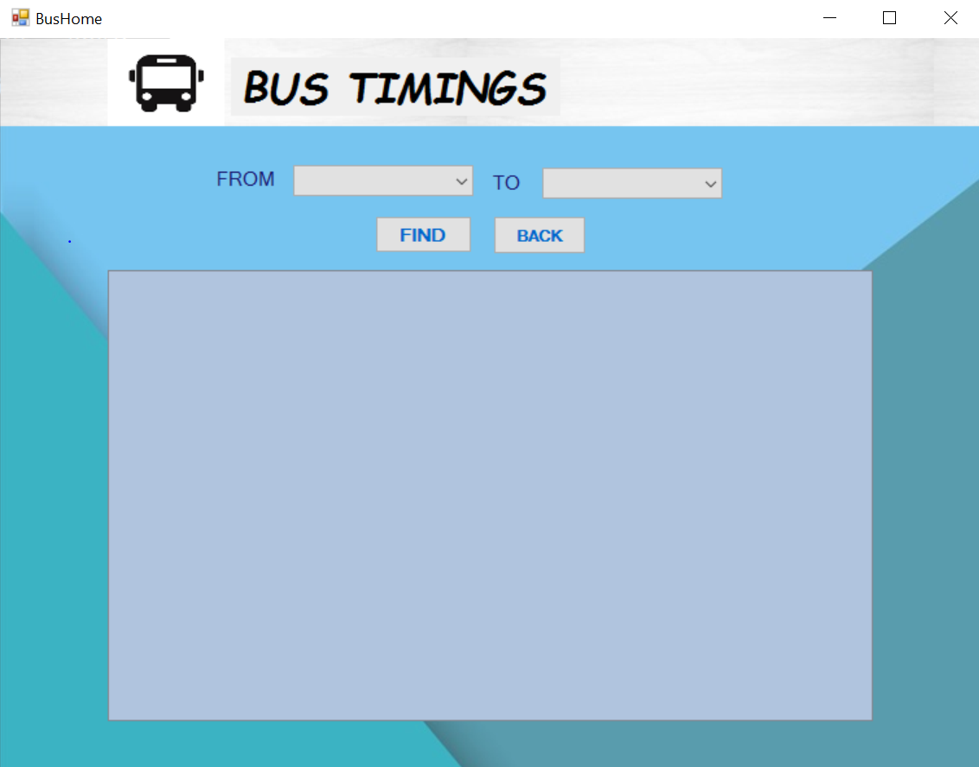

Bus Services page allows you to search for the buses which travel from the location from where you want to start and to your destination.

## FROM

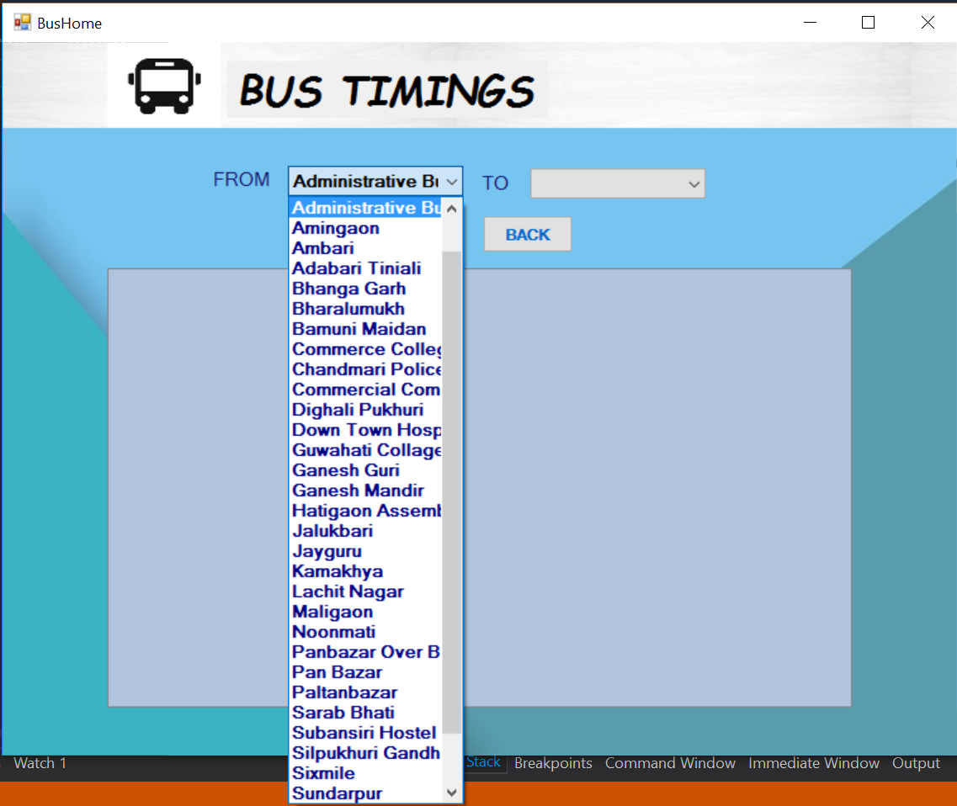

* Click on the down arrow icon which is located to the right side of the FROM label to choose the current location from where you want to travel.

## TO

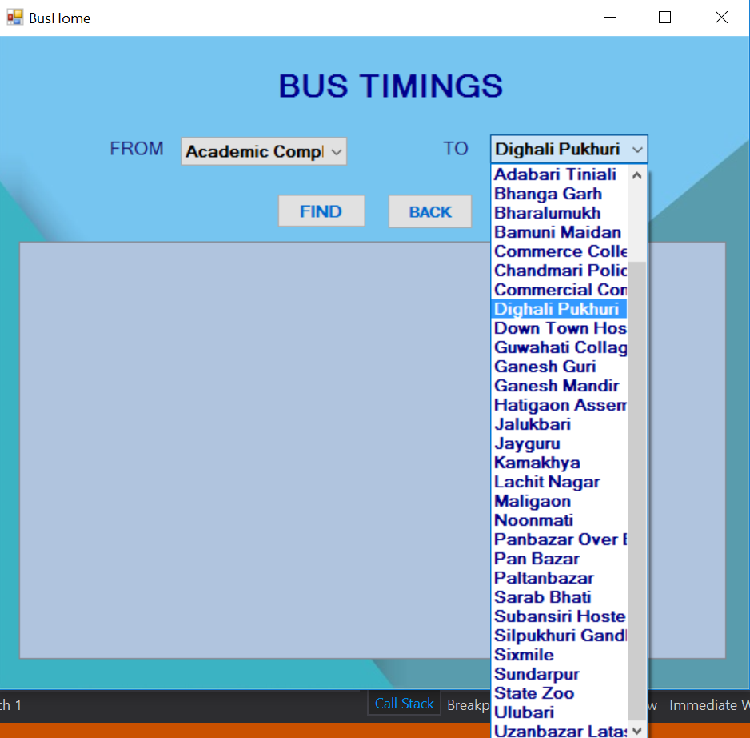

* Click on the down arrow icon which is located to the right side of the TO label to choose your destination.

## FIND

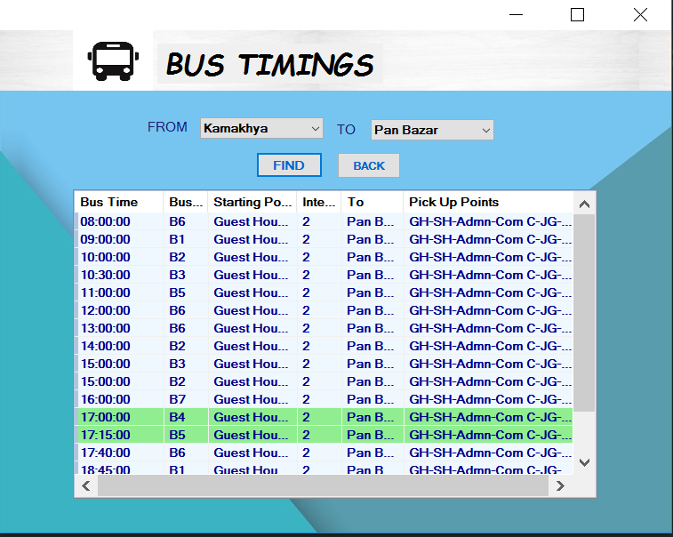

* Click on the FIND button to display the details of the buses which travel from your location to the destination selected by you.
* Bus Time, Bus number, Starting Point, Intermediate number of stops, To, Pick Up Points will be displayed in the list view form.
* All the buses which will leave in about thirty minutes or less with respect to the current time will be highlighted with green colour.

## BACK

* Click on the back button to exit the application.

# Long Distance Cabs

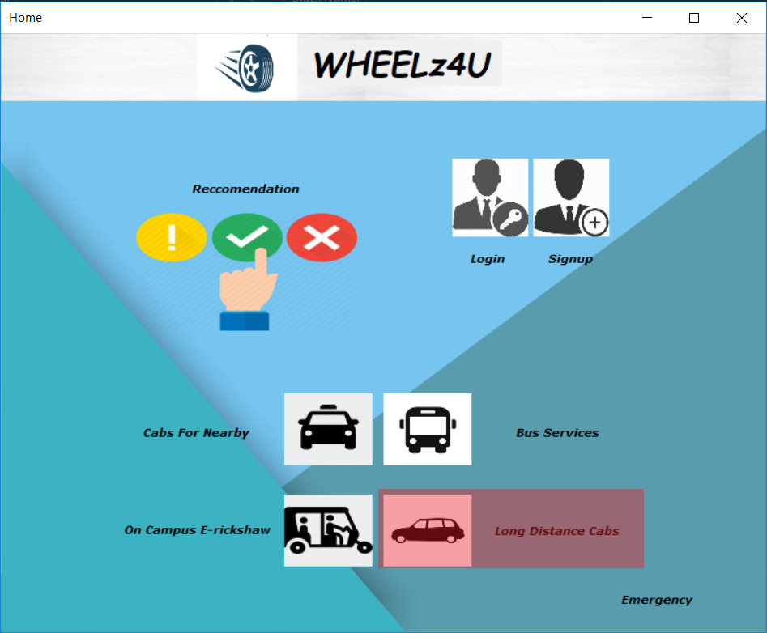

Click on the Long Distance Cabs to search for the cabs and it will open the window displayed below.

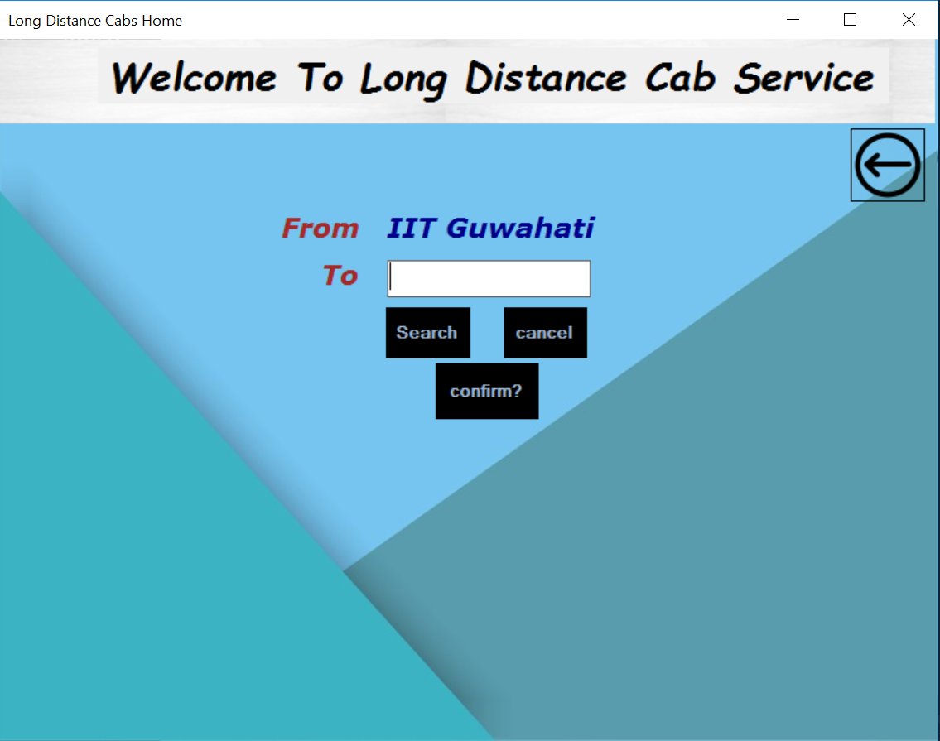

## Search

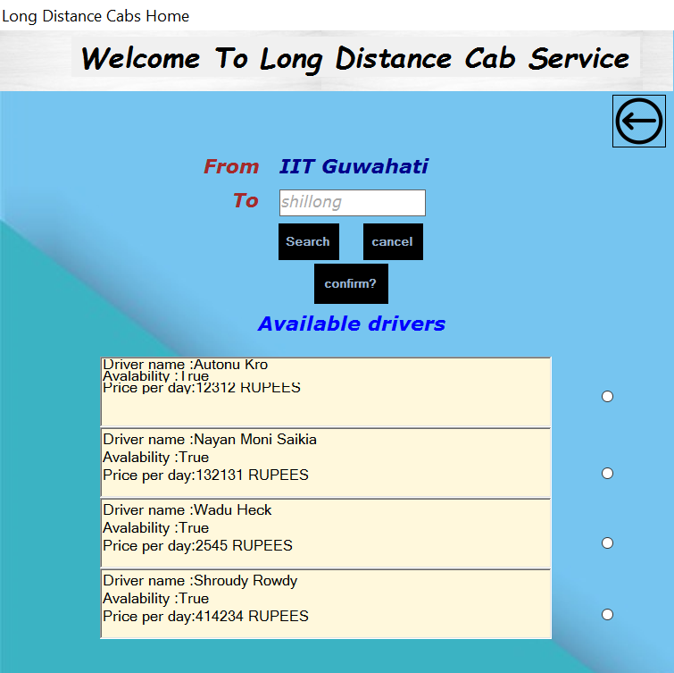

* Enter your destination and click on the search button to search for the cabs which will travel from IIT Guwahati to your destination.
* Driver names, Availability and Price per day will be displayed.

## Confirm

* Select the cab by clicking on the radio button which is visible to the side of the details.
* After selecting the cab then click on the confirm button.
* If you are not logged in then a message will be shown “Please Log in to Book a Cab”.

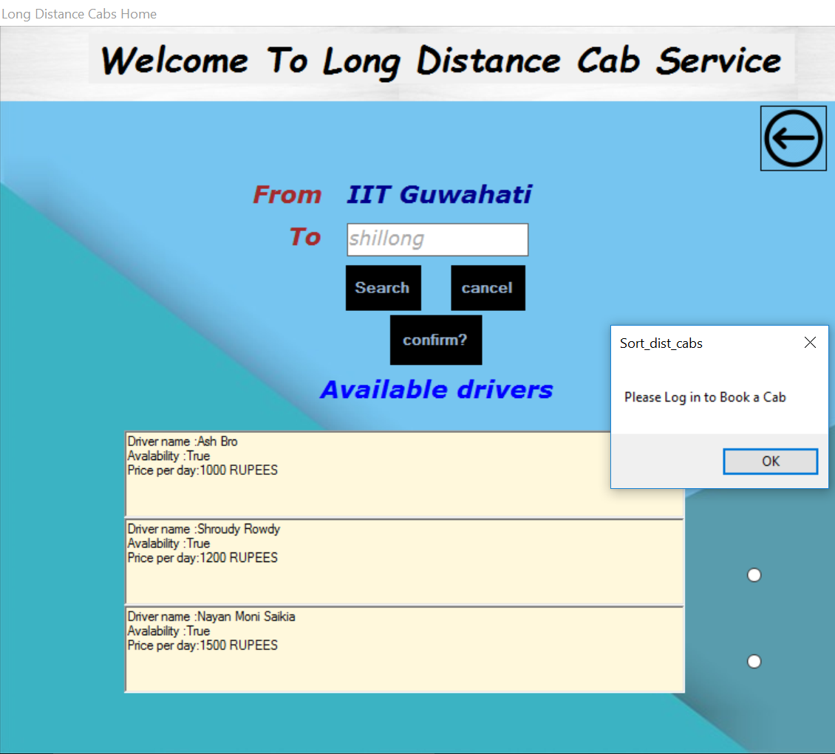

* If you select ok then it will go to the login window as shown below.

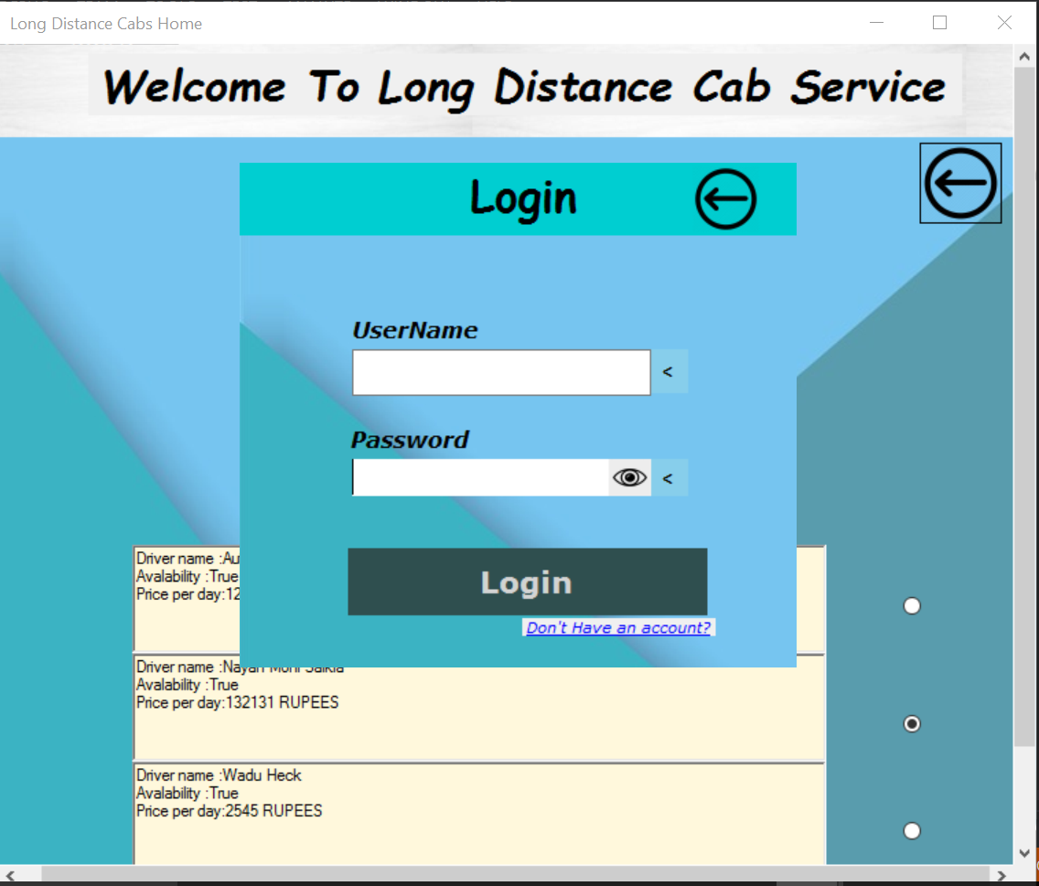

* If you are already logged in then a new window will be displayed in which you can select the number of days you want to stay.

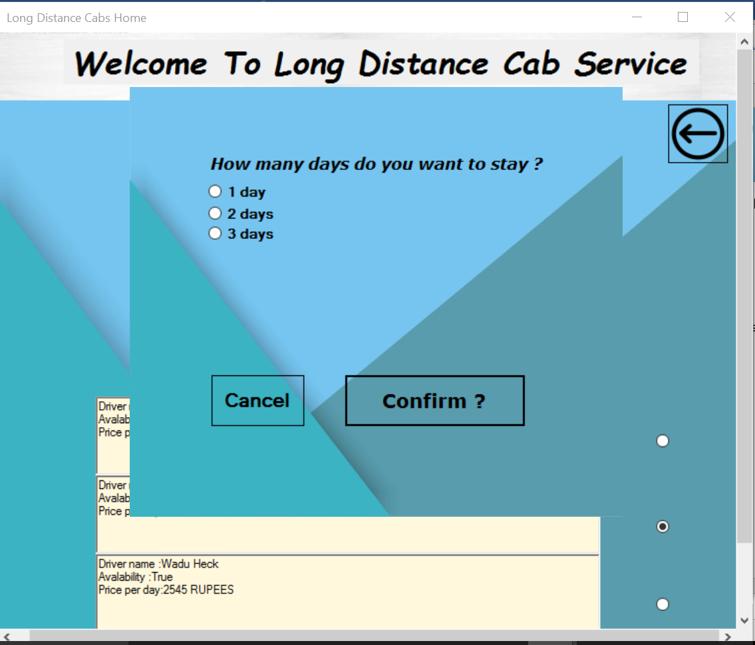

* After selecting one of those options the price charged by the driver will be displayed.

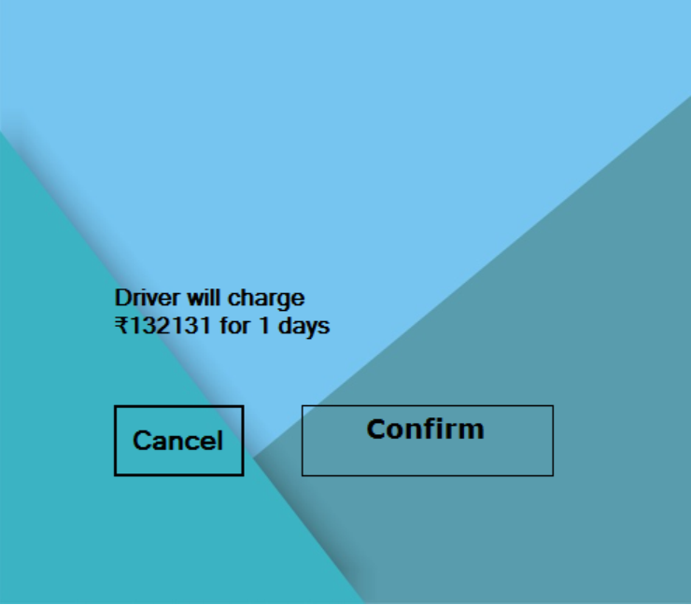

* And then you can click on the confirm button the book the cab and then the message will be displayed on the screen “Booking is done”. You can also cancel the booking instead of selecting the confirm button.

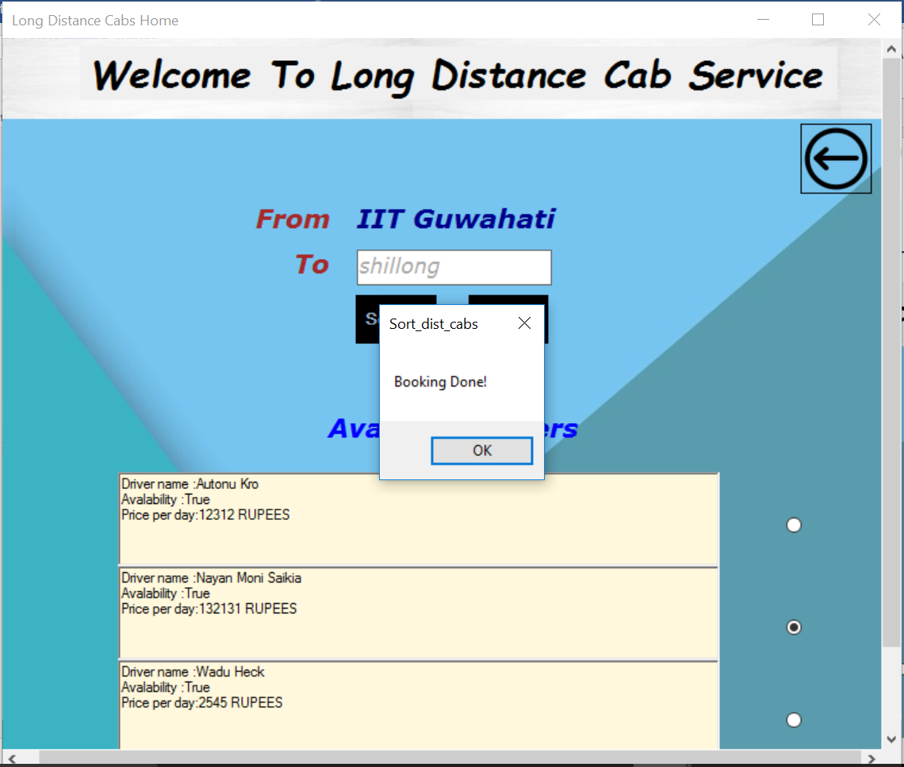

### BACK

* Click on icon which is displayed on the right corner of the window to go back to the previous windows.

# Campus E-rickshaw Services

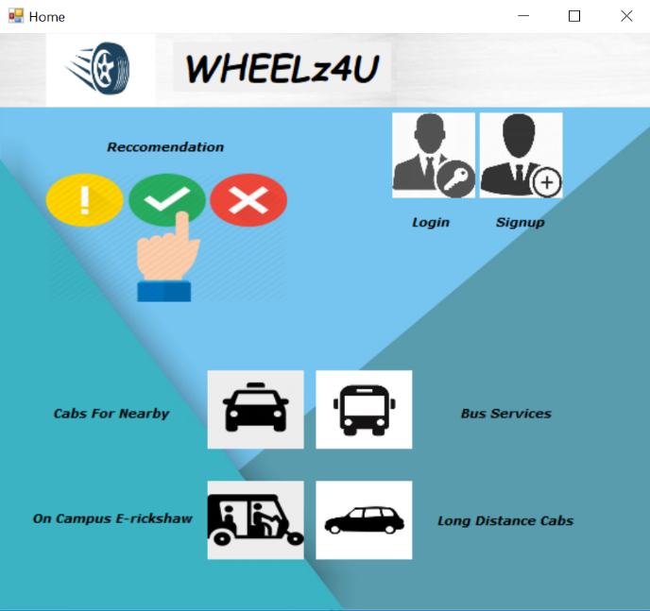

E-rickshaw button

**On clicking the button for E-rickshaw, booking Panel appears. Users may select their locations from IITG Campus map.**

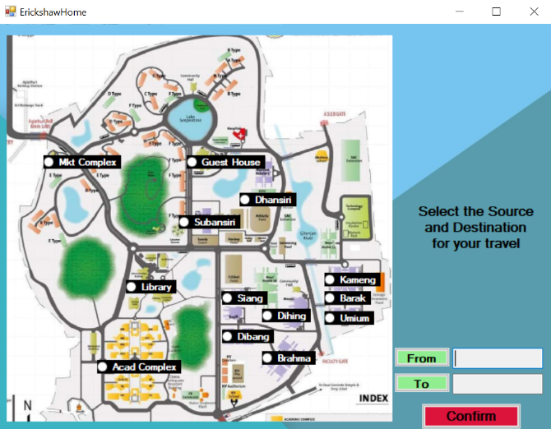

IITG Map

**First, select your current location on the map and press the “FROM” button**

**Then, select your destination and press the “TO” button**

**Finally, click on “Confirm”**

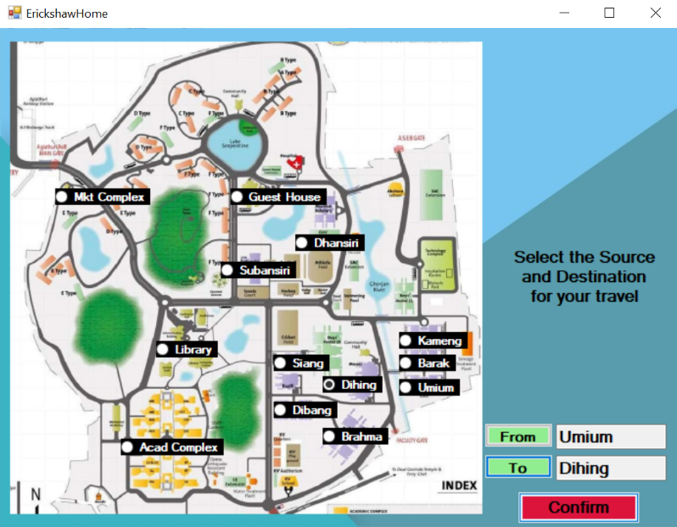

**Now, a recommended driver will appear in a new form, who is precisely the one that is closest to your current location**

**Along with that, there is also a list of other available drivers displayed below, which have been sorted in increasing order of their distance from your current location**

**You can choose to call any driver as per your convenience.**

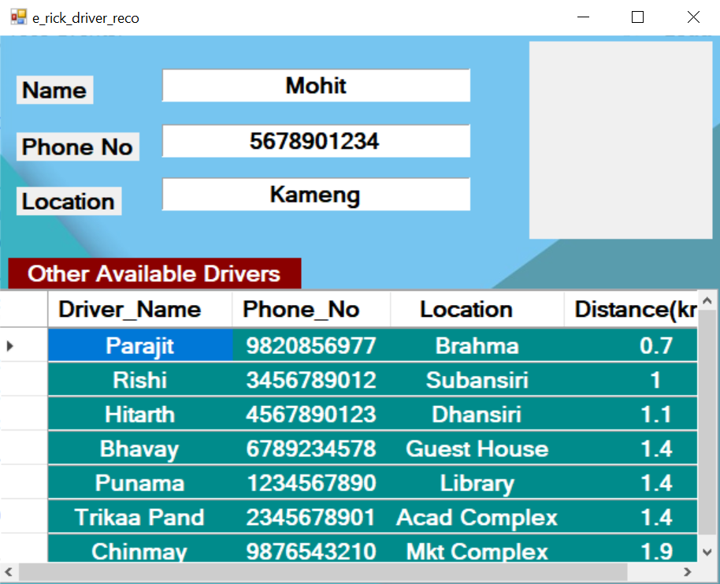

Other Available Drivers

Recommended Driver

# Emergency

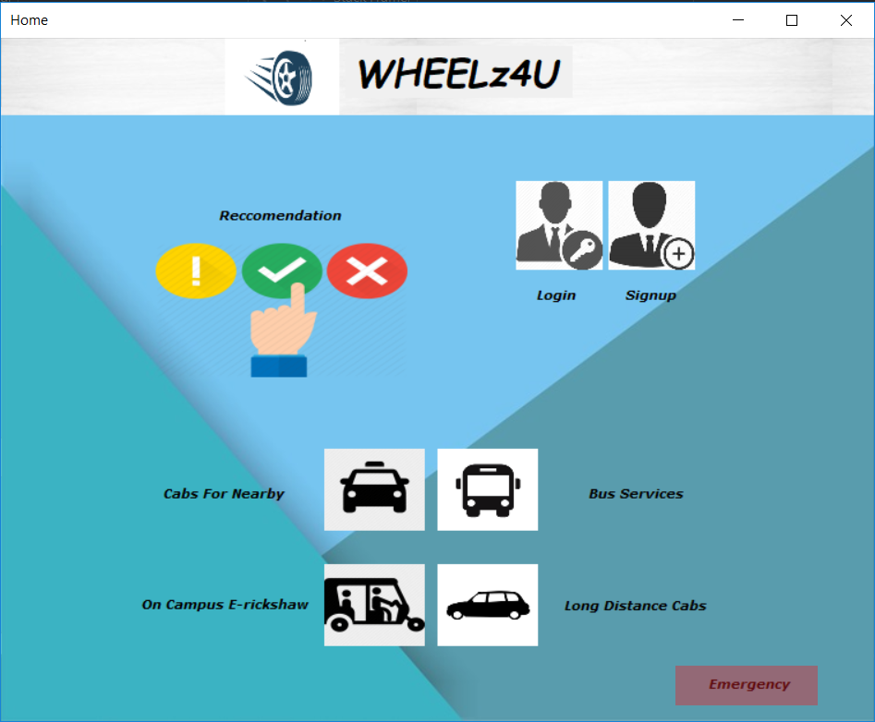

Select the Emergency button to open the window displayed below.

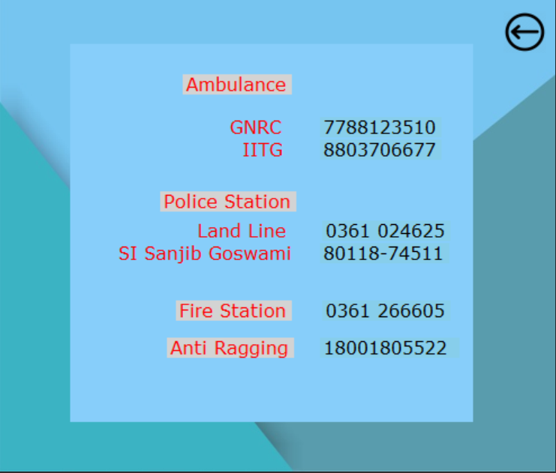

All the information related to emergency services will be displayed. All the contact numbers of the ambulance, police station, fire station and anti-ragging will be displayed.